Павел Стойчев - Surbahar: кратка биография 2022
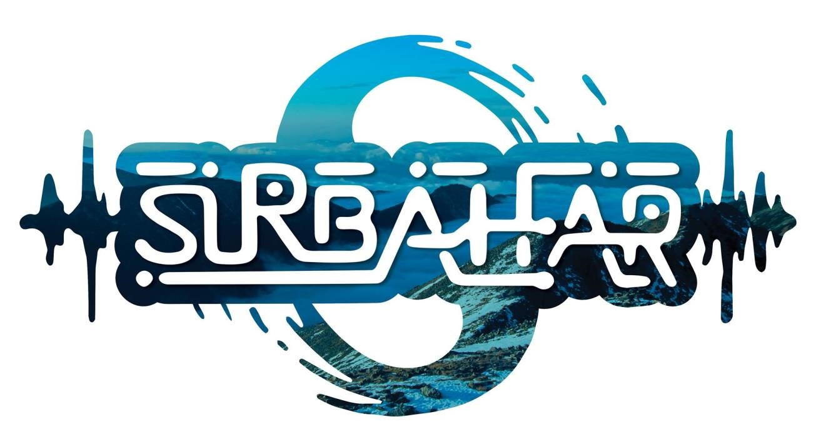

Pavel Stoychev is a musician, composer and sound director from Sofia.
Surbahar is one of his original projects, which he has been developing since 2002. With him, he participated in a number of international festivals, and in 2007 he signed a contract with one of the largest music labels for electronic-acoustic music in India - Chill Om Records, after which he participated in the release of two compilations - Azaa-de 2007 and Swaa-Raj - 2008. In 2009, he made his first one-month tour in the big cities of India, where he was welcomed extremely warmly by the local public and press. His participation was reflected on national television and an article in Rolling Stone Magazine - India, as well as later in Rolling Stone magazine - Bulgaria.
The musicians who participated in the recording of the first released album - The Om Remains the Same 2010:
Maria Lukova – violin,
Miky Megre (ex Band of Mad Women) – vocals;
Miroslav Tsvetkov – guitar;
Kliment Dichev – programming and piano;
Francisco Alvazar (POR) – trombone;
Yasen Mischuk – kaval

Since the beginning of 2018, Pavel has been working on a new album and performing with various musicians under the name Surbahar Live Band, in the form of:

Desislava Petrova – vocal;
Orlin Tsvetanov – violin;
Miroslav Tsvetkov – guitar;
Roman Kurylenko (Russia) – kaval, saxophone;
Eli Balarama Selesao Lara (Mexico) - saxophone;
Dimitar Bakardjiev – saxophone, flute;
Georgi Gogov – clarinet, synthesizers;
Daniel Eliseev – guitar;
Vladi Mihailov – viola;
Nikolay Ivanov – guitar;
Konstantin Kuchev – violin;
Dario Tabakov – clarinet, trumpet;

Current lineup for 2023
Desislava Petrova - vocal
Isabel Sokol-Oxman - gadulka, violin, vocals
Damian Diaz Merlis - kaval, trumpet
Dimitar Bakarjiev – flute, sax
Miroslav Tzvetkov - guitar
Pavel Stoychev - Surbahar - programming, synths, percusion

SURBAHAR Live Band's music combines various acoustic and electric instruments with modern electronic forms. Stylistically, the music is oriented towards ambient, chill, ethno, world, jazz, idm, trance.
Pavel says about himself: "My inspiration is nature and the science of inner knowledge. Our consciousness has many questions whose answers we have forgotten. The music I create helps me remember them."
Surbahar's second double album is expected to be released in 2023.

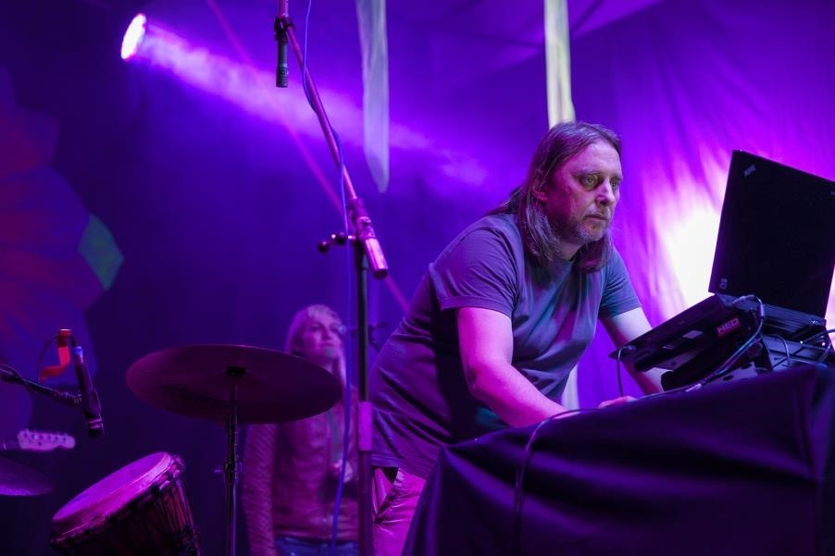
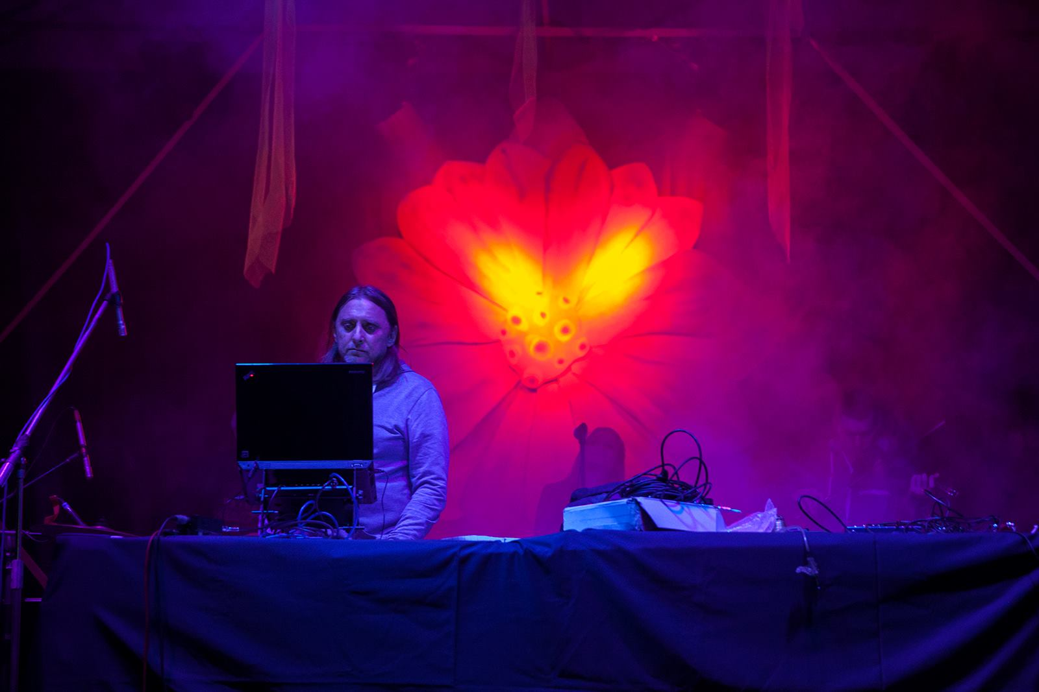
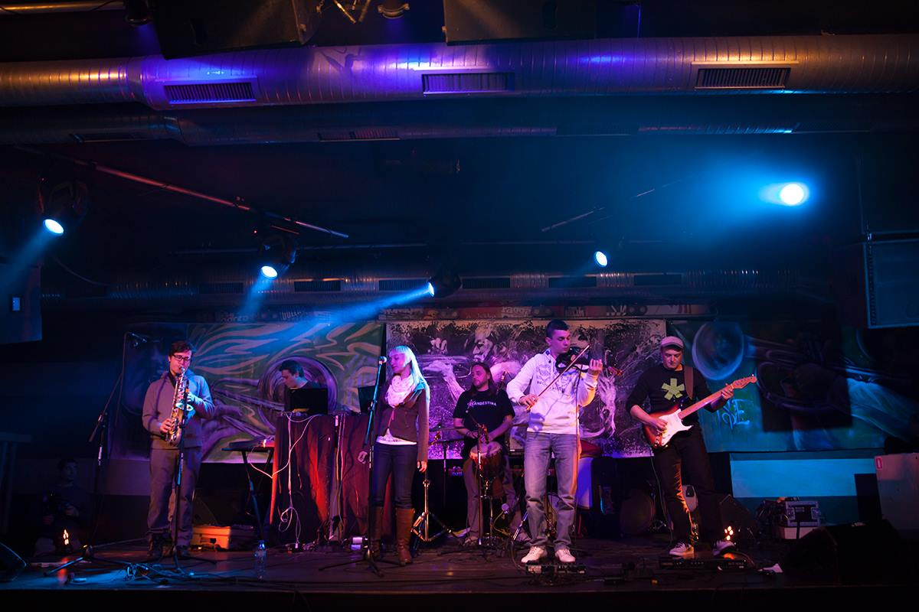

Фестивали и Турнета:
Ozora festival (HU)
No Mans Land festival (HU)
Transylvania Calling festival (RO)
Gathering of the Tribe (GER)
Ultimae Label Gathering (POR)
Sziget festival (HU)
Sofia International Film festival (BG)
Surbahar India tour 2009 – Goa – Kolkata – Bangalore – Mumbai (IND)
Artmospheric festival (BG)
Mellow festival (BG)
Tangra festival (BG)
Space of Joy (UKR)
In the Palace – international film festival (BG)
Beglika festival (BG)
Sunny Moon festival (BG)
Earth Dance festival (BG)
Wrong fest (BG)
Poetics festival (BG) and more

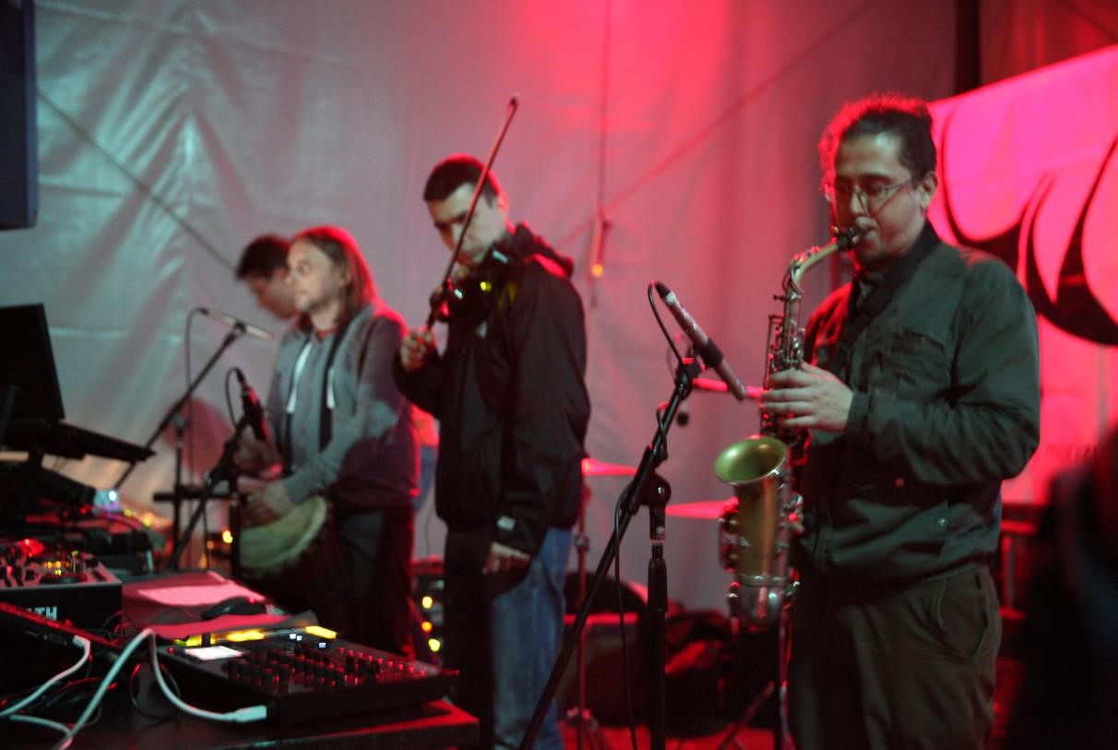
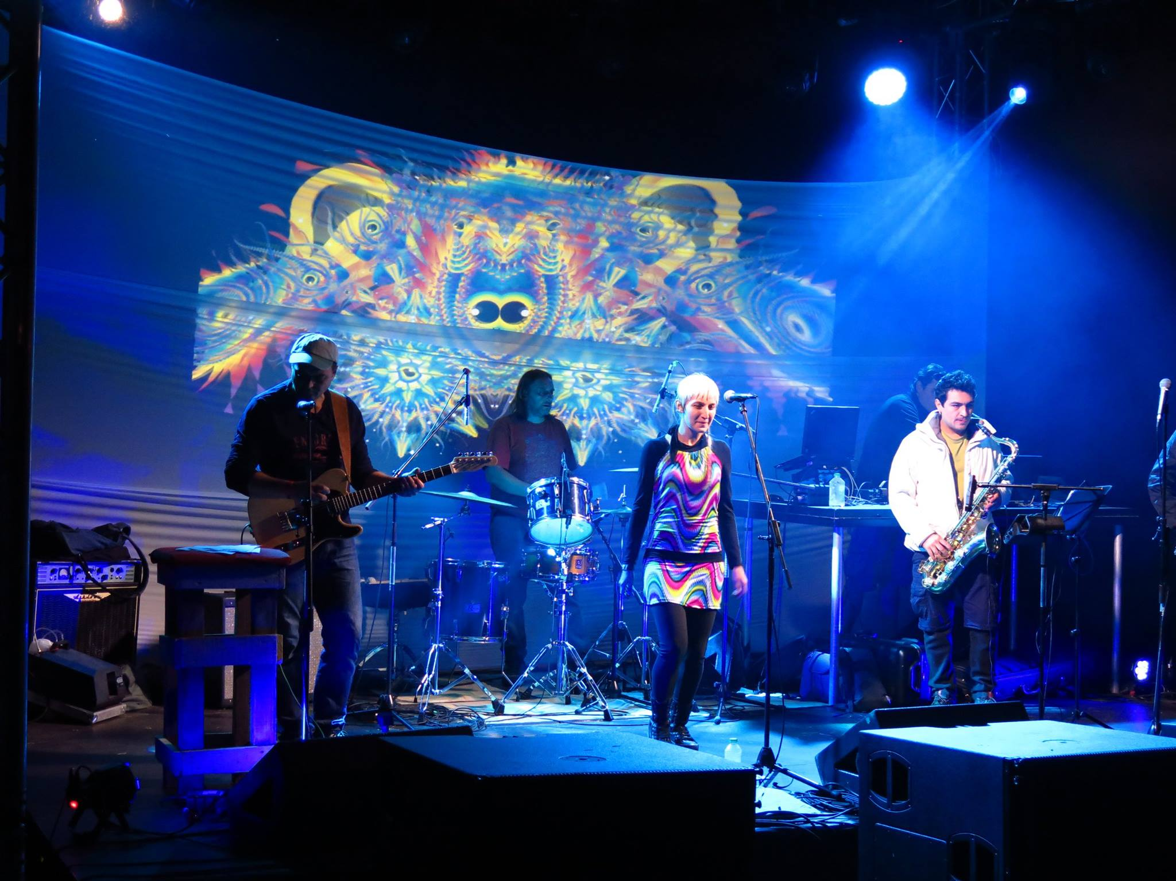
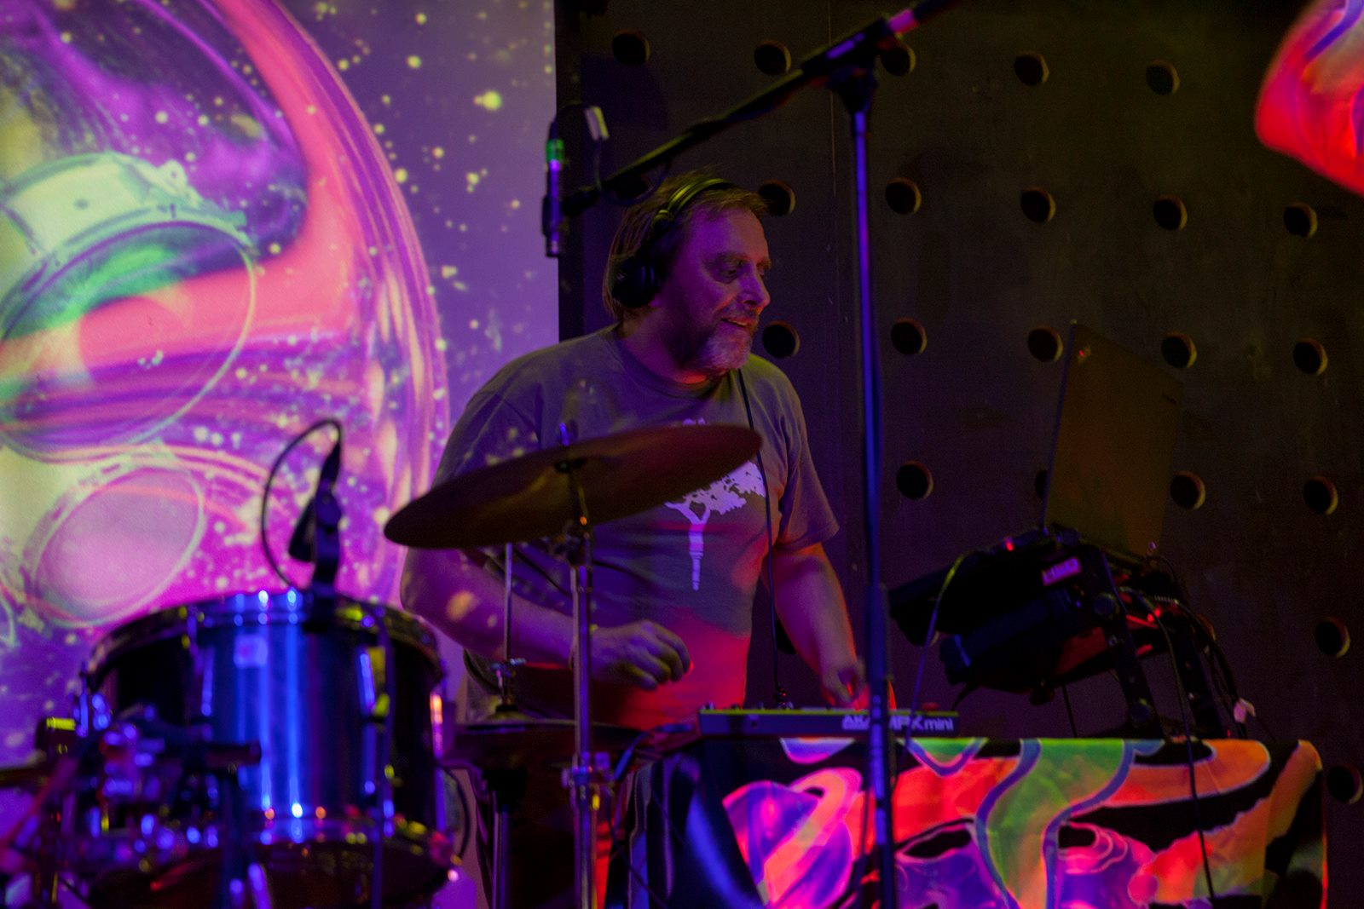

От 2002 година Павел участва и в други два проекта - Pumpal & TubeFx с които изнася редица концерти.
TubeFx е авторски проект, който постепенно прераства в музикална формация, концертираща на живо. Групата има множество клубни и фестивални изяви в страната. През 2008 издават първия си и единствен засега албум в Ouim Net label .
Pumpal – група, позната ни от финалите на конкурса “Вашата Нокиа Сцена” 2006, където се класират на шесто място. Pumpal участвaт на финалите за 70 годишнината на ежегодния пролетен конкурс на БНР с песента Бяла Луна. През 2020 година излезе и първият им авторски албум с името Grateful.
Други групи и проекти:
TFSL (Tales from The Sleeping Land) – psychedelic rock & blues, stoner, trip hop (2018 – 2020) участия на множество фестивали и турнета в страната.
The Elephant of The Princes (2016 – 2020) - psychedelic rock, trip hop, alternative – участия на концерти и фестивали в София и Русе.
Samodelia откриват програмата на главната сцена на международния фестивал EXPO 2001 пред 4000 души, след което следват участия на Crossing Bridges festival – Пея, Косово и Sziget festival – Budapest и други. През 2001 година издават два албума Ouim Net label.
Band of Mad Women с които печели голямата награда и тази на публиката на конкурса “Звукът на Паспорт” 1999, емблематична за времето си формация, участвала нееднократно на най-големия фестивал в Източна европа – Sziget festival.
Bluba Lu – барабанист и съавтор в първия албум на групата “Bluba Lu in Wonderland”, както и в единствения за времето си независим български музикален лейбъл – Yello Music.
Art Locomotion - барабанист и съавтор в първия албум на проекта.
https://surbahar.bandcamp.com/
https://soundcloud.com/tubefx/
https://pumpal.bandcamp.com/
https://artlocomotion.bandcamp.com/
http://artmospheric.org

София, 2022

